Indiana State Parks
Camping Guide
- 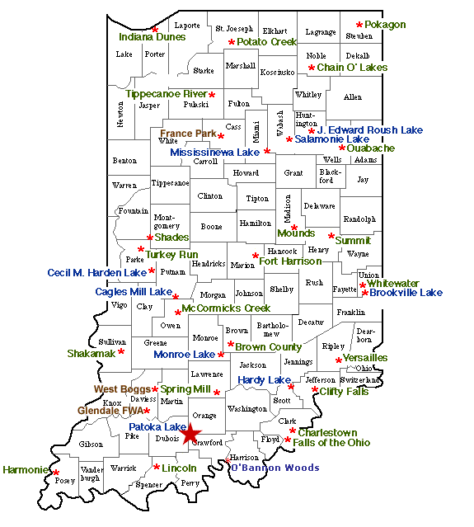
Campground reservations
Northern Parks
Chain O' Lakes North page 3
Harmonie North page 4
Indiana Dunes North page 5
Pokagon North page 6
Potato Creek North page 7
Tippecanoe River North page 8
J. Edward Roush Lake (Huntington Lake) North page 9
Mississinewa Lake North page 10-11
Salamonie Lake North page 12

Eastern Parks
Charlestown East/South page 13
Versailles East/South page 14
Whitewater Memorial East/South page 15
Brookville Lake East/South page 16-17
Ouabache East/North page 18

Campground reservations

Southern Parks
Brown County South page 19
Clifty Falls South page 20
Falls of the Ohio South page 21
Lincoln South page 22
Shakamak South/West page 23
Spring Mill South page 24
O'Bannon Woods South page 25
McCormick's Creek South/West page 26
Hardy Lake South/East page 27
Monroe Lake South page 28
Patoka Lake South page 29
Western Parks
Prophetstown West/North page 30
Shades West page 31
Turkey Run West page 32
Cagles Mill Lake West page 33
Cecil M. Harden Lake (Raccoon SRA) West page 34
Central Parks
Fort Harrison Central page 35
Mounds Central page 36
Summit Lake Central page 37
Chain O' Lakes
Activities and Facilities
- Boat Launch Ramp
- Boating / Elect. motor only
- Nature Center/Interpretive Naturalist Services (Seasonal)
- Shelters
(Shelter Reservations)
- Rental-Canoe, Paddleboat, Rowboat Canoe rental on weekends & holiday by the hour only
- Cross County Skiing / No Ski Rental
- Fishing / Ice Fishing
- Hiking Trails
- Swimming / Beach
- Cabins
- Cabin Reservations
- Campground Reservations
- Local map
- Local tourism info
- Regional tourism info
- Property Map
- Electric/ Non-electric/ primitive Google Map

- 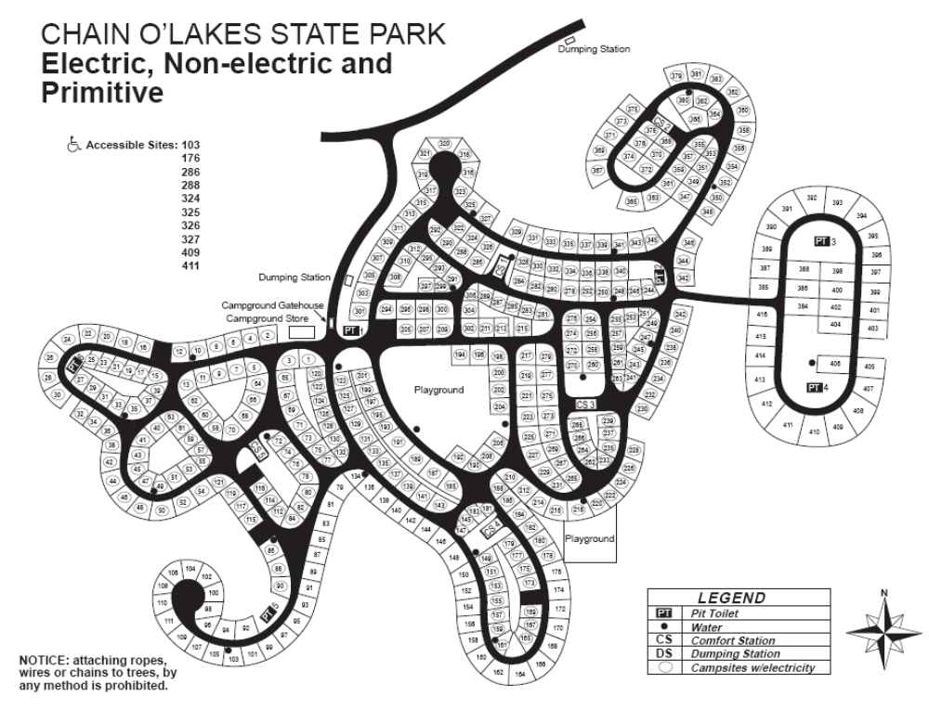

Harmonie
Activities and Facilities
- Boat Launch Ramp / Wabash River
- Fishing
- Nature Center/Interpretive Naturalist Services (seasonal)
- Shelters (Shelter Reservations)
- Picnicking
- Bridle Trail
- Bicycle Trail
- Hiking Trails
- Swimming / Pool / Waterslide (See Swim Alert)
- Electric / 200 sites
- Youth Tent Areas
- Camp Store
- Campground Reservations
- Dumping Station
- Campground reservations
- Local map Property Map
- Local tourism info
- Regional tourism info
- Electric Google Map

- 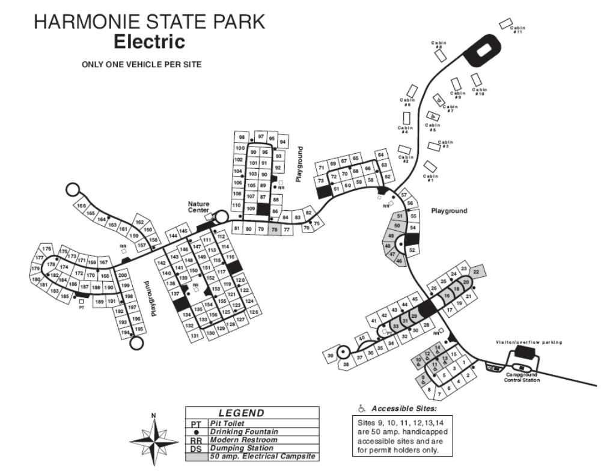
Indiana Dunes
Activities and Facilities
- Nature Center/Interpretive Naturalist Services (hours : 9:30am - 4:30pm local time)
- Picnicking/Shelters
(Shelter Reservations)
- Access to Calumet Trail (9 miles of hiking)
- Cross-country Skiing (trails available, no ski rental)
- Fishing (Smelt Only)
- Hiking Trails
- Swimming / Beach (See Swim Alert)
- Electric - 140 (all 50 amp service)
- Youth Tent Area
- Campground reservations
- Local map Property Map
- Local tourism info
- Electric Campground Google Map

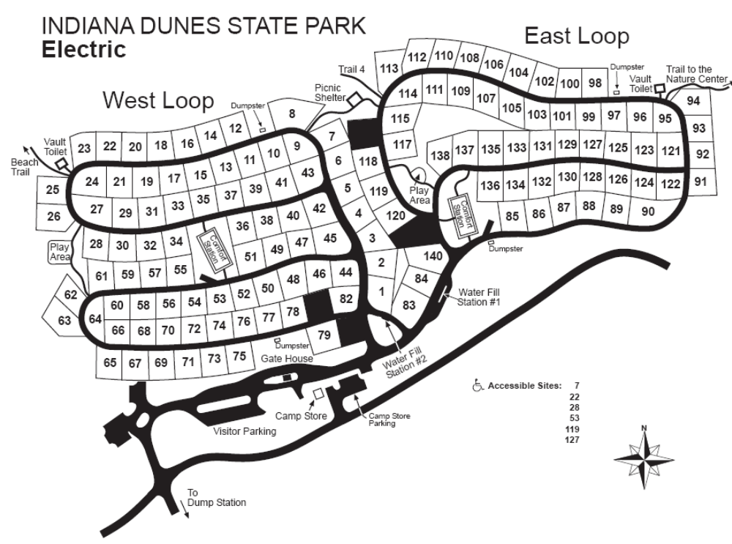
Pokagon
Activities and Facilities
- Cross Country Skiing
- Nature Center/Interpretive Naturalist Services
- Picnicking/Shelters
(Shelter Reservations)
- Meeting & Conference Facilities
- Picnicking
- Playground Equipment
- Rental - Paddleboat, Rowboat & Pontoon
- Rental - Recreation Building
- Saddle Barn with escorted rides (260) 833-6007
- Sand Volley Ball Court
- Swimming / Beach (See Swim Alert)
- Toboggan Run (seasonal)
- Potawatomi Inn
- Inn & cabin reservations
- Campground & group camp reservations
- Local map Property Map
- Electric non-electric Google Map

- 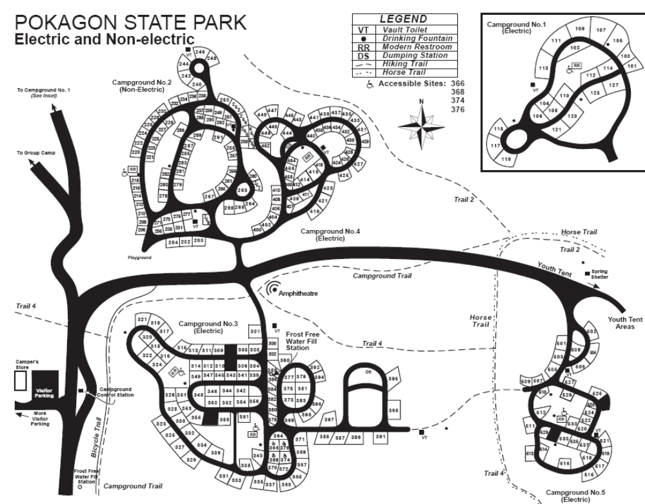
Potato Creek
Activities and Facilities
- Nature Center/Interpretive Services
- Picnicking/Shelters
(Shelter Reservations)
- Bicycle Trail / 3.2 miles
- Boat Launch Ramps / 2 Boat Motor / Electric trolling only
- Bridle Trails Cabins / 17 Cross-country Skiing / No Ski Rental
- Fishing / Ice Fishing / Fishing Pier Fish Cleaning Station Hiking Trails
- Mountain Bike Trail / 6.6 miles Playground Equipment
- Rentals Bicycle Canoe, Paddleboat, Rowboat, Kayak, Trolling Motors Recreation Building
- Swimming / Beach Local map Local tourism info Regional tourism info Property Map Cabin floor plan Electric Google Map
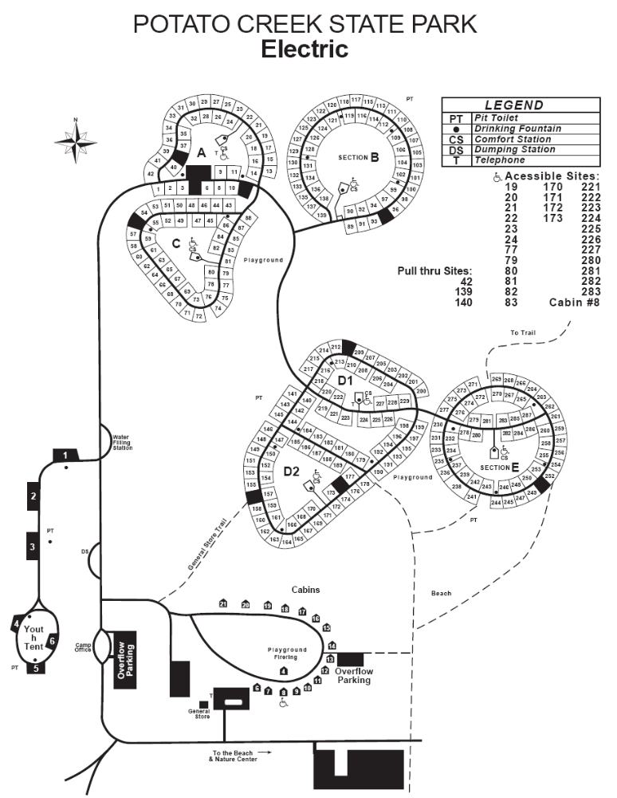
Tippecanoe River
Activities and Facilities
- Picnic areas w/shelters
(Shelter Reservations)
- Interpretive Naturalist Services
- Boat Launch Ramp
- Bridle Trails
- Cross County Skiing / No Ski Rental
- Fishing
- Hiking Trails
- Rental - Recreational Building
- Electric / 112 sites Horsemen's / 56 sites - primitive Canoe Camp / 10 sites
- Rent-A-Camp Cabins Group Camp Youth Tent Areas Dumping Station
- Campground Reservations Local Map Property Map Regional tourism info Electric campground
- Google Map

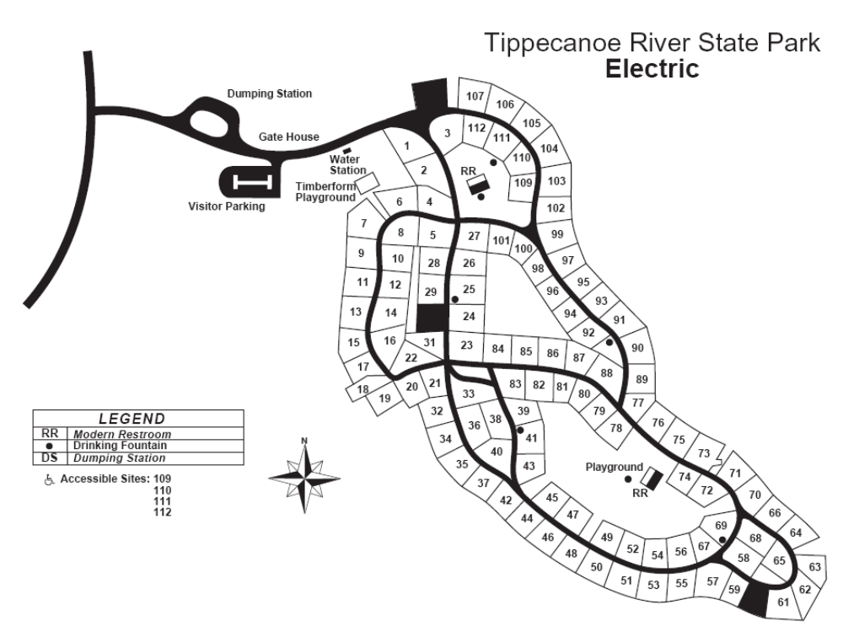

J. Edward Roush Lake (Huntington Lake)
Activities and Facilities
- Archery Range
- Basketball Courts / 3 (Beach & Campground) Mountain Bike Trail Boating / 2 Launch Ramps
- Fishing / Ice Fishing Fishing Pier / Corps Pond
- Accessible Fishing Piers (2) Hiking Trails (Reservable Shelters)
- Hunting (Mandatory check station)
- Division Interpretive Services Property Interpretive Services
- Radio-Control Flying Field
- Paid Pheasant Hunting
- Picnicking / Shelterhouse (Shelter Reservations)
- Playground Equipment
- Shooting Range
- Swimming / Beach (See Swim Alert) Waterskiing
- Campground Reservations
- Shooting Range
- Local map Property Map Kil-So-Quah primitive Google Map

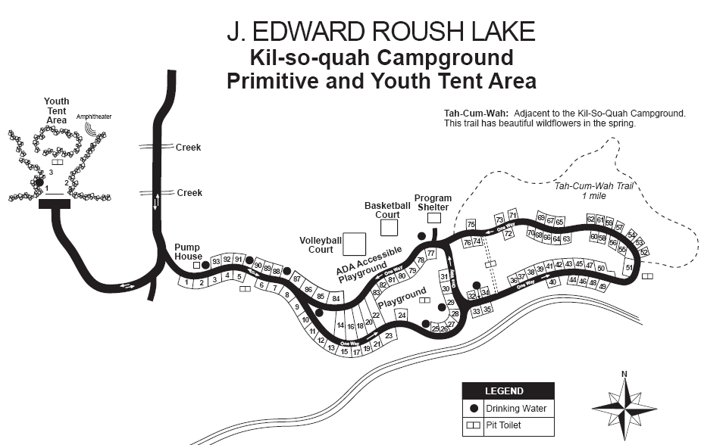

Mississinewa Lake
Activities and Facilities
- Basketball Court, Horseshoes & Volleyball at Campground
- Boating / 4 Launch Ramps / Marina
- Fish Cleaning Station
- Fishing / Ice Fishing
- Fishing Piers / 2
- Frisbee Golf Course
- Hiking Trails Frances Slocum SRA
- Hunting
- Division Interpretive Services
- Property Interpretive Services
- Picnicking / Shelterhouse (Shelter Reservations)
- Playground Equipment
- Radio-Control Flying Field
- Swimming / Beach (See Swim Alert)
- Volleyball at Beach & Campground
- Waterskiing
- Campground Reservations
- Local map
- Property Map
- Electric, non-electric
- Full hookup electric, non-electric
- Google Map
- Campground reservations

Two maps for the total camping area (see below)
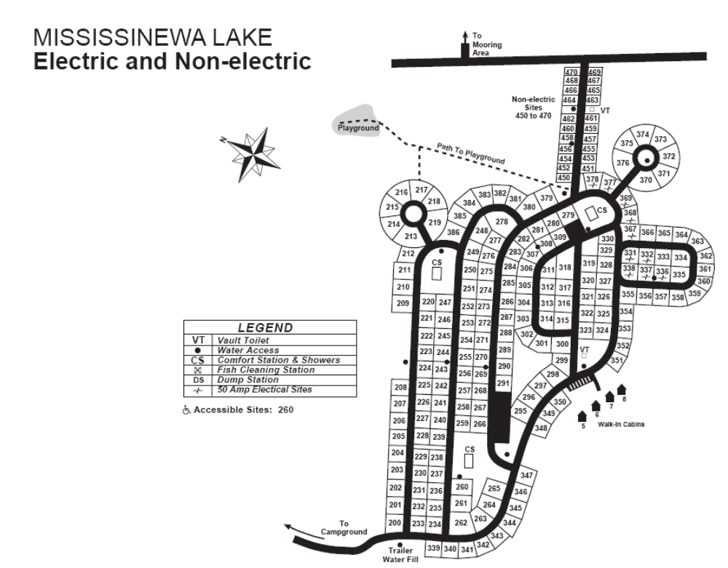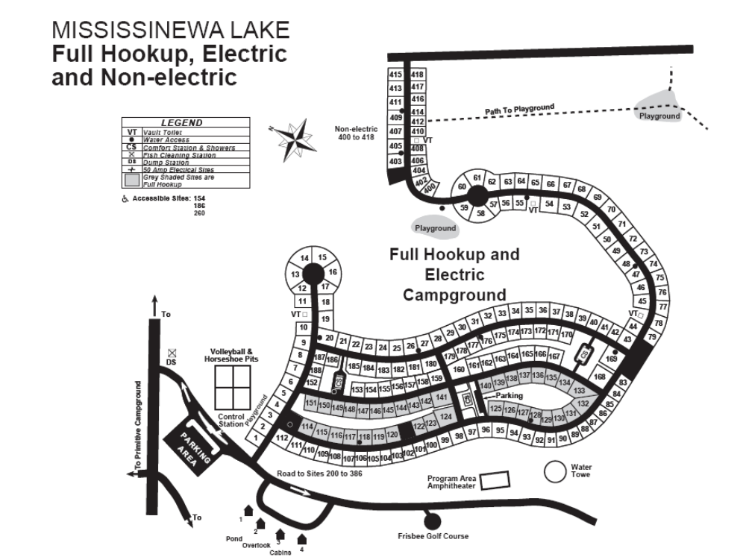
Salamonie Lake
Activities & Facilities
- Amphitheatre
- Basketball Courts Biking Trails
- Boating / Launch Ramps/ Marina (salamoniemarina.com/) Bridle Trails
- Canoeing/kayaking Cross-country Skiing - no rental
- Fishing / Ice Fishing Fishing Pier (open when water level permits)
- Hiking Trails Horseshoe Pits
- Hunting / mandatory check stations Division Interpretive Naturalist Services
- Property Interpretive Naturalist Services Mountain Biking (Bloodroot Trail)
- Nature Center Picnicking / Shelterhouse (Shelter Reservations) Playgrounds
- Snowmobile Trails Swimming / Beach (See Swim Alert)
- Volleyball Courts Waterskiing
- Campground Reservations Local map Property Map & Info
- Lost Bridge West electric Google Map
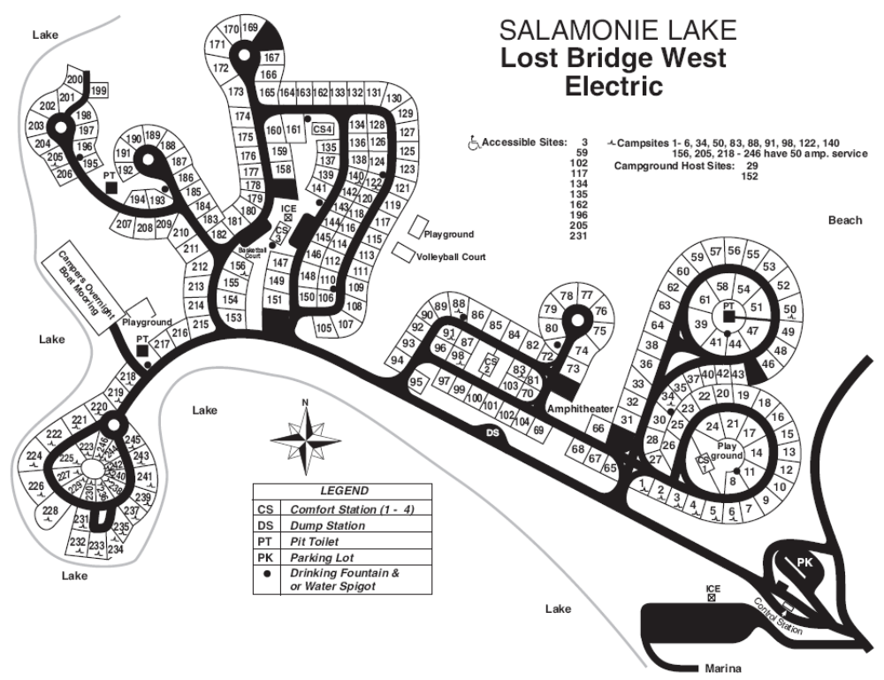

Charlestown
Activities and Facilities
- Hiking Trails
- Picnic areas w/shelters (Shelter Reservations)
- Fishing, along 14 Mile Creek bank on Trail 3
- Playground Equipment
- Camping
- Interpretive Naturalist Services (seasonal)
- Campground Reservations
- Local map
- Local tourism info
- Regional tourism info
- Property Map
- Google Map

- 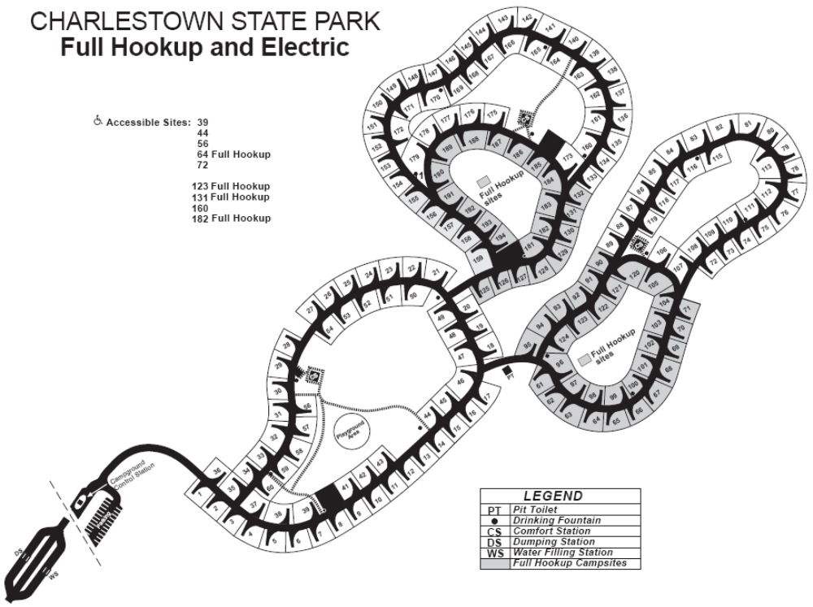

Versailles

Activities and Facilities
- Picnic areas w/shelters
(Shelter Reservations)
- Interpretive Naturalist Services (Seasonal)
- Boat Launch Ramp
- Boat Motor / Electric trolling only
- Bridle Trails (day use only)
- Saddle Barn (closed for 2008)
- Fishing Hiking Trails
- Mountain Bike Trails
- Rental-Canoe, Paddleboat, Rowboat, and Kayak Rental - Recreation Building
- Swimming / Pool / Waterslide (See Swim Alert) Local Map Property Map
- Local tourism info
- Electric A, B, C camp Google Map Campground reservations

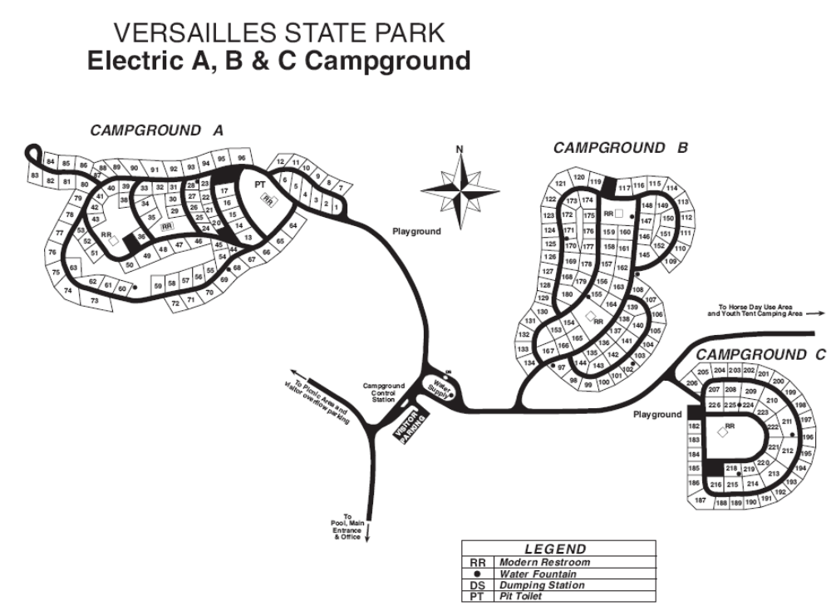

Whitewater Memorial
Activities and Facilities
- Picnic areas w/shelters
(Shelter Reservations)
- Interpretive Naturalist Services (Seasonal)
- Boat Launch Ramp (2) / 1 Whitewater Lake, Brookville Lake
- Boat Motor at Brookville Lake / Electric trolling only at Whitewater Lake
- Fishing / Ice Fishing Hiking Trails Rental-Canoe, Paddleboat, Rowboat Swimming / Beach
- Saddle Barn with escorted rides
http://www.guidedtrailridesllc.com/, (765) 458-6035
- Local Map Property Map
- Electric, non-electric Horsemen's primitive Youth Tent Campground reservations

- Google map
Brookville Lake
Activities and Facilities
- Archery
- Boating / 9 Launch Ramps
- Fishing / Ice Fishing
- Hiking Trails
- Horseshoe Pits
- Hunting Interpretive Naturalist Services Quakertown Marina, Inc.
- Kent's Harbor Marina
  - The Sagamore Resort
  - Ainsley's Cafe
  - Buck Point Golf Course
-- a P.B. Dye Course --
- Picnicking / Shelterhouse
- Playground Shooting Range
- Swimming / Beach (See Swim Alert)
- Volleyball Waterskiing
- Local map Local tourism info Regional tourism info
- Property Map Google Map
- Mounds electric Mounds full hook-up electric Quakertown electric Campground reservations
- 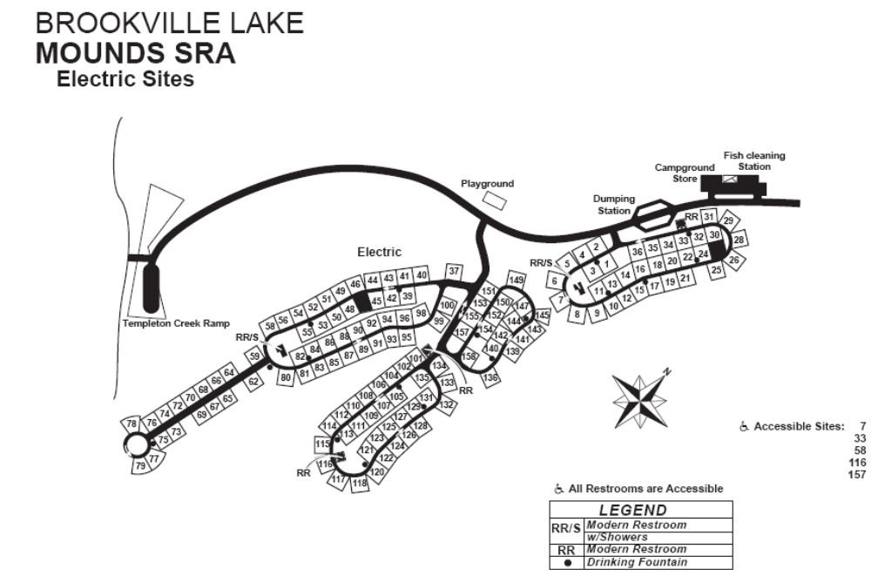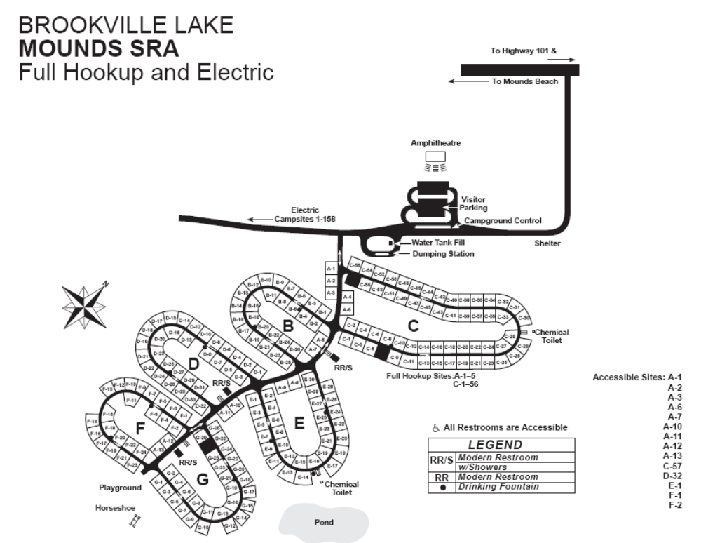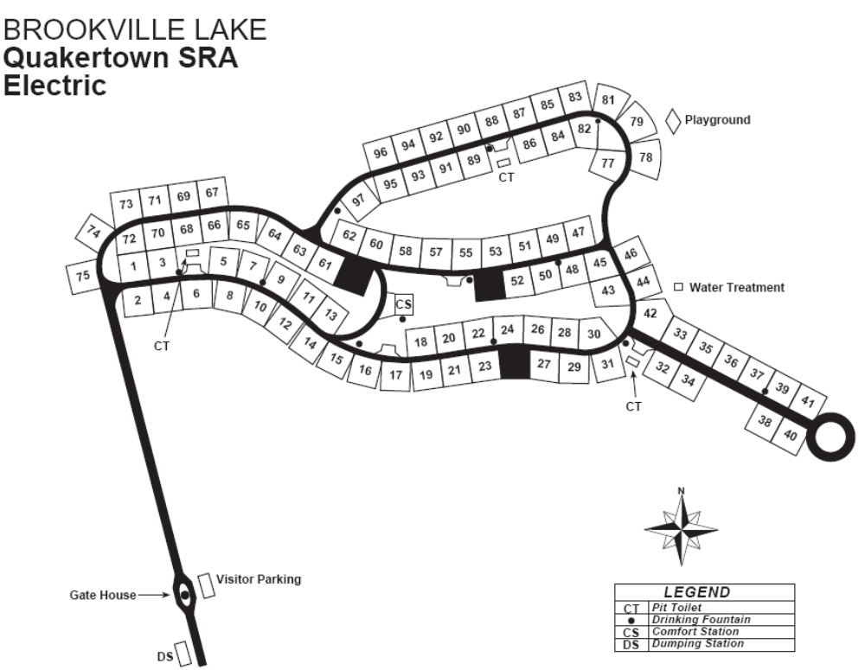
Ouabache
Activities and Facilities
- Nature Center/Interpretive Naturalist Services (seasonal)
- Picnicking/Shelters (Shelter Reservations) Picnic Tables Fishing / Boating
- Hiking Trails Paved Bicycle Trail
- Swimming Pool
- Tennis Courts Basketball Courts
- Volleyball Court Playgrounds Local map Regional tourism info Property Map Youth tent
- Electric Google Map
- Campground reservations

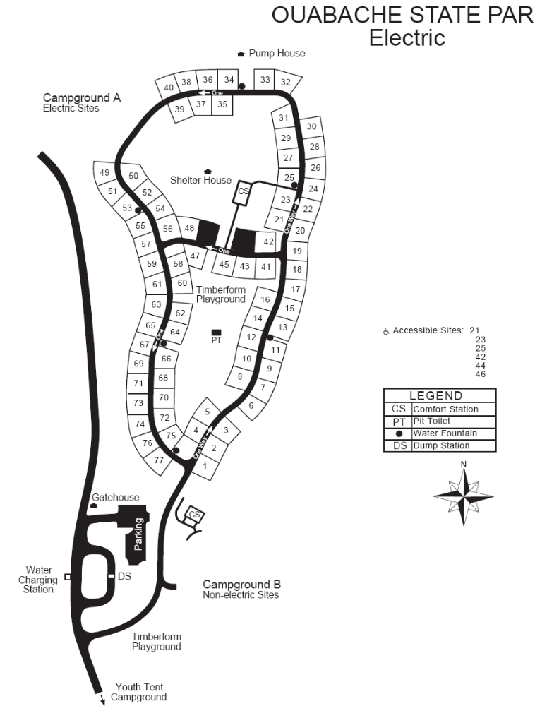
Brown County
Activities and Facilities
Nature Center/Interpretive Naturalist Services
Shelters
(Shelter Reservations)
Bridle Trails / Saddle Barn, www.browncountysaddlebarn.com
(with escorted rides: (812) 988-8166 )
Picnic Tables Fishing / Ice Fishing Hiking Trails Mountain Bike Trails Tennis Courts Open Fields
Playground Equipment Swimming / Pool (See Swim Alert)
- Local map Property map Campground reservations
Local tourism info Regional tourism info
Buffalo Ridge electric Horse electric Horse primitive Google Map
- Raccoon Ridge electric Rally and youth tent areas Taylor Ridge electric
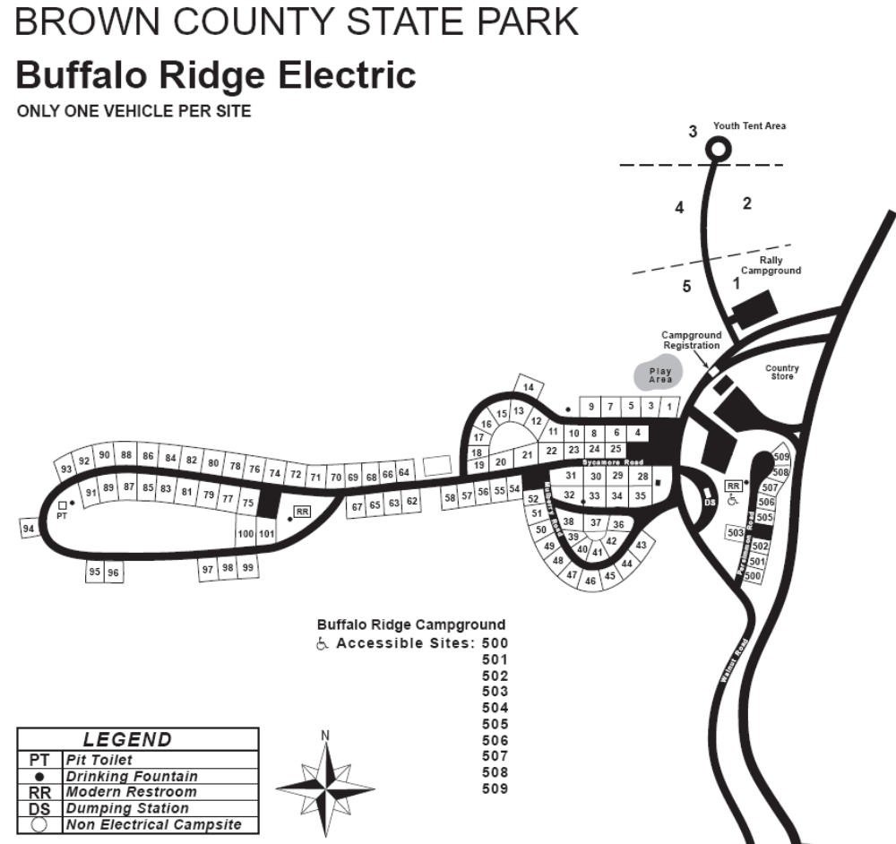
Clifty Falls
Activities and Facilities
Nature Center/Interpretive Naturalist Services
Shelters
(Shelter Reservations)
Picnicking Hiking Trails Tennis & Other Games
Meeting & Conference Facilities
Clifty Inn and Restaurant
Swimming Pool / Waterslide
Open Memorial Day (See Swim Alert)
- Clifty Inn
- Inn Reservations
- Campground Reservations
- Local map Property Map
- Local tourism info
- Regional tourism info Electric Google Map
- 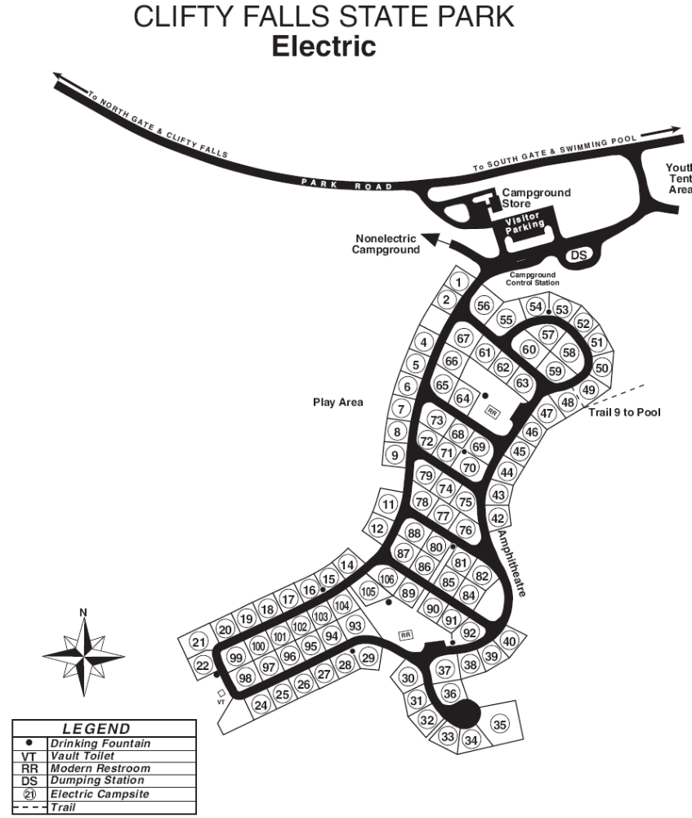

Falls of the Ohio
Activities and Facilities
- Hiking Trails
- Picnic areas
- Fishing
- Education Programs
- Boat Launch Ramp/Ohio River
- Interpretive Naturalist Services
  - Special programs & events
  - George Rogers Clark cabin
- Local map
- Local tourism info
- Regional tourism info
- More info: Falls of the Ohio
- Property Map (trails) Campground reservations Google Map

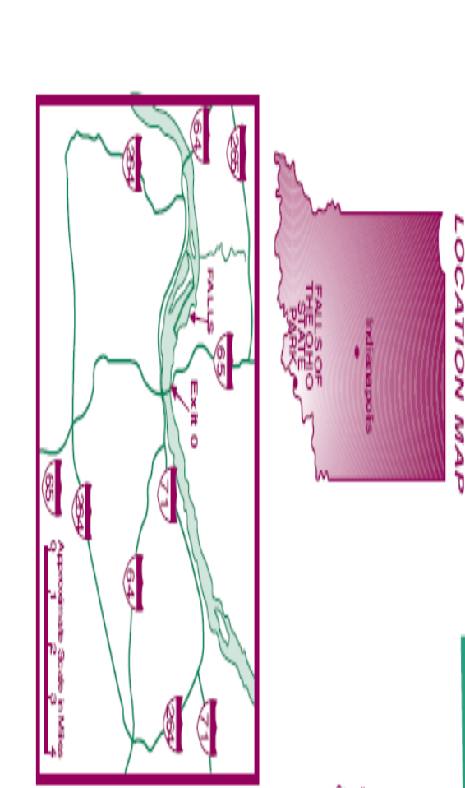
Lincoln
Activities and Facilities
- Nature Center Interpretive Naturalist Services (Seasonal)
- Picnicking/Shelters
(Shelter Reservations)
- Boat Launch Ramp
- Boating / Elect. motor only Fishing
- Shelters (Shelter Reservations) Hiking Trails
- General Store Rental-Canoe, Paddleboat, Rowboat
- Swimming / Beach (See Swim Alert)
  - Lincoln State Park beach is open Memorial Day Week-end through Labor Day Week-end
- Cabins Cabin Reservations Campground Reservations
- Property Map Local map
- Local tourism info Regional tourism info
- Buckhorn primitive Buckhorn youth tent
- Blue Heron Cabins map Blue Heron Cabin floorplan
- Group Cottages 5, 9
- Group Cottage 1 Group Cottages 2, 3, 4, 13, 14, 15
- Group Cottages 6, 7, 8, 10, 11, 12
- Pine Hills Group Cottages map Lake Lincoln Electric Gobbler's Run Primitive Google Map
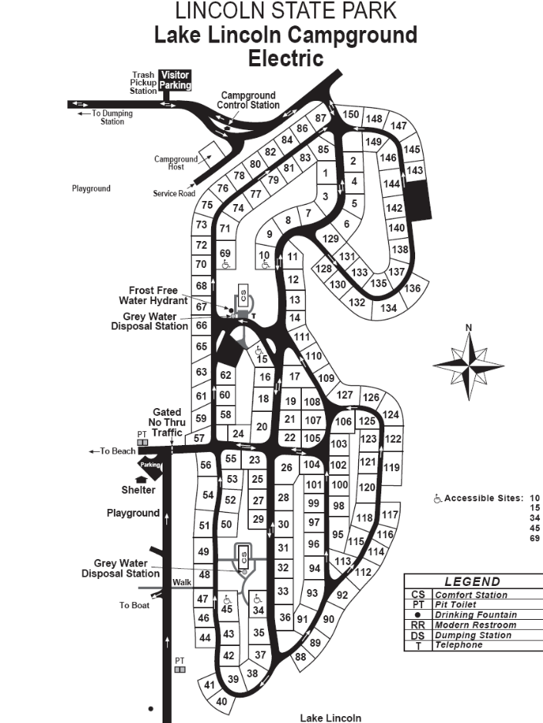

Shakamak
Activities and Facilities
- Picnic areas w/shelter (Shelter Reservations)
- Nature Center/Interpretive Naturalist Services (Seasonal)
- Boat Launch Ramp Boating Motor / Elect. trolling only
- Saddle Barn with escorted rides (812) 665-2203
- Cabins reservable Fishing / Ice Fishing Hiking Trails
- Rental - Paddleboat, Rowboat Rental - Recreation Building
- Tennis Swimming / Pool / Water slide (See Swim Alert)
- Cabins
- Cabin & Campground Reservations
- Local Map
- Local tourism info
- Regional tourism info
- Property Map Cabin map
- Cabin 1 floor plan Cabin 9 floor plan Cabins 10-26 floor plan Cabins B C floor plan Cabin D floor plan
- Electric Rent-a-camp Group camp Google Map
- 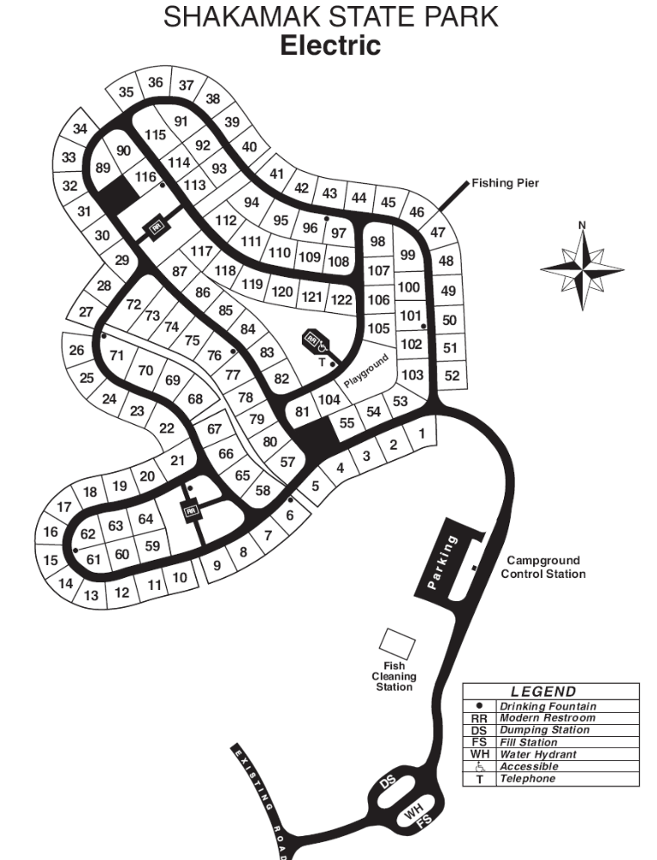

Spring Mill
Activities and Facilities
- Cave River Valley Natural Area - Preliminary Site Management Plan
- Picnic areas w/shelters
(Shelter Reservations)
- Nature Center/Interpretive Naturalist Services
- Boat Motor / Electric trolling only
(limited access) Caves / Donaldson & Twin
- Fishing / Ice Fishing Hiking Trails
- Mountain Bike Trails (bike rental available) Grissom Memorial
- Inn Accommodations Inn Restaurant
- Meeting & Conference Facilities
- Pioneer Village / Grist Mill Volleyball & Other Games Swimming / Pool (See Swim Alert)
- Spring Mill Inn
- Inn Reservations Campground Reservations
- Local Map Local tourism info Regional tourism info
- Property Map
- Electric Electric & primitive
- Primitive Youth tent Google Map
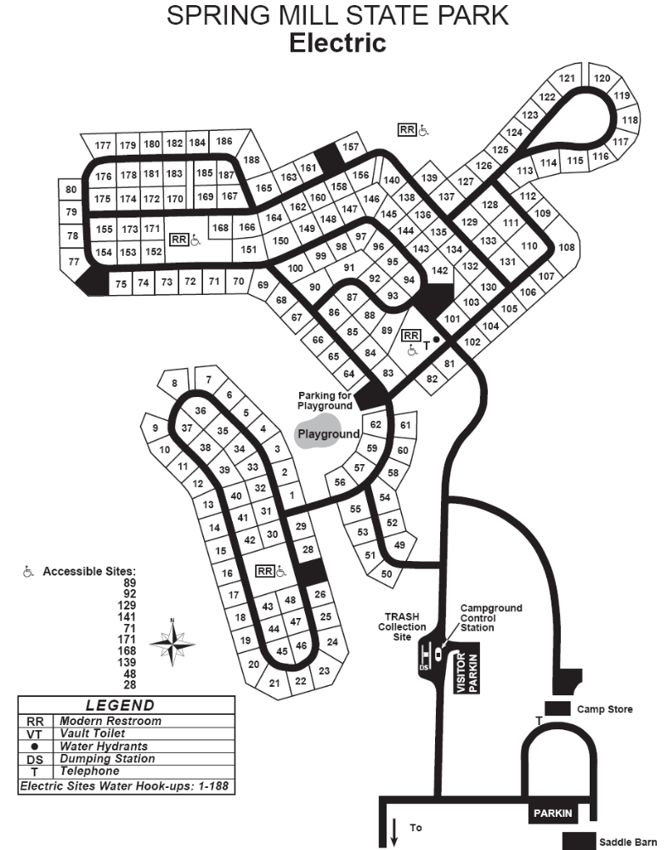
O'Bannon Woods

Activities and Facilities
- Nature Center/Interpretive Naturalist Services
- Picnicking/Shelters (Shelter Reservations)
- Horse Trails
- Picnic Tables
- Fishing / Boating
- Hiking Trails
- Local map Property Map
- Local tourism info
- Regional tourism info
- Wyandotte Caves info Campground reservations
- Electric all Electric A, B, C camp
- Horsemen's Electric D camp Group camp
- Stagestop Primitive Campground Horsemen's primitive Google Map
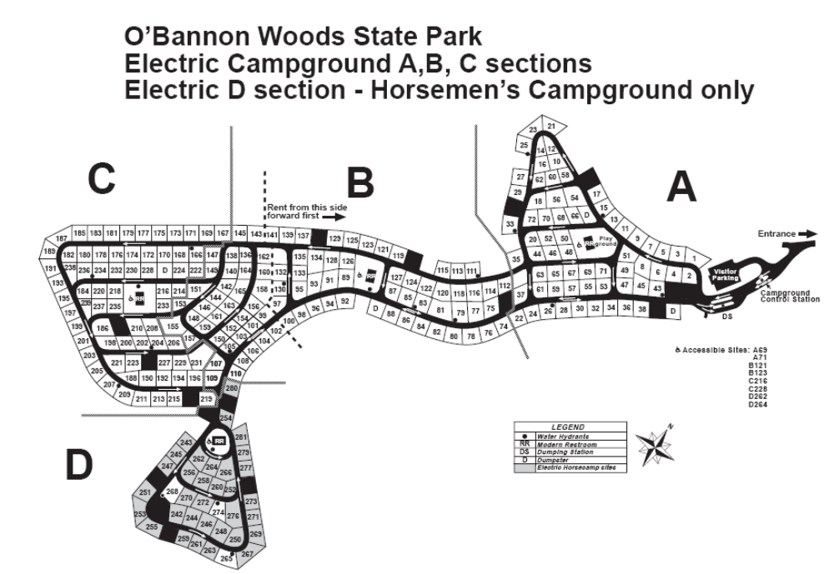

McCormick's Creek
Activities and Facilities
- Nature Center/Interpretive Naturalist Services
- Picnicking/Shelters
(Shelter Reservations)
- Hiking Trails
- Saddle Barn & trail rides (812) 829-8848
- Tennis Courts
- Recreation Buildings
- Recreation Center
- Swimming / Pool (See Swim Alert
- Property Map Local map
- Cabins 1-6, 8-14 floorplan
- Cabin 7 floorplan
- Electric
- Primitive
- Youth tent
- Canyon Inn
- Inn Reservations
- Meeting & Conference Facilities
- Cabins
- Campground &Cabin Reservations Google Map
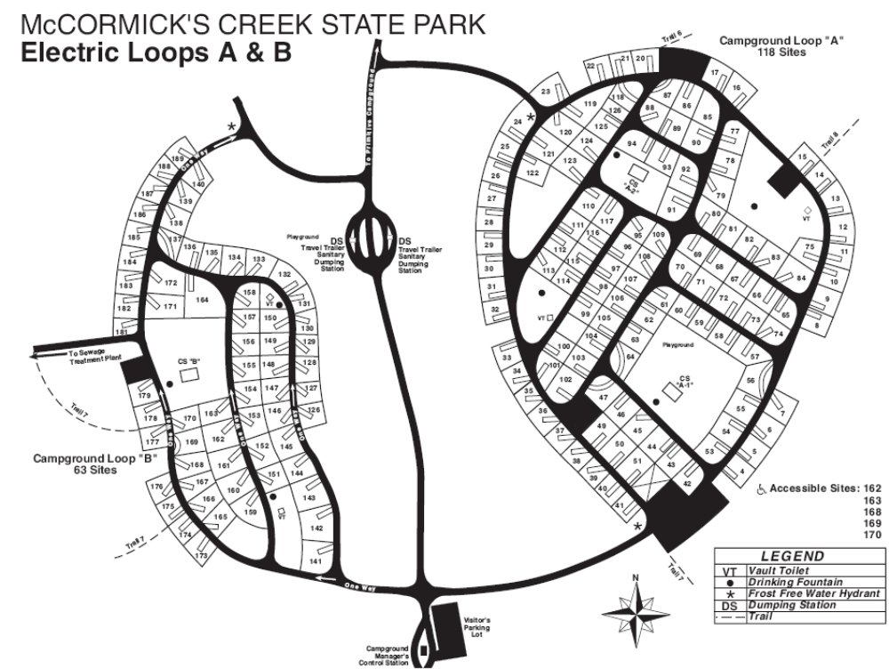
Hardy Lake
Activities and Facilities
- Archery Range
- Basketball Courts
- Open Playfield Volleyball Courts
- Boating / 4 Launch Ramps Fishing / Ice Fishing Fishing Pier
- Hiking Trails Hunting
- Interpretive Services
- Picnicking / Shelterhouse Playgrounds Rental - Rowboat
- Swimming / Beach (See Swim Alert) Waterskiing
- Local map Property Map
- Shale electric Wooster primitive Campground reservations Google Map
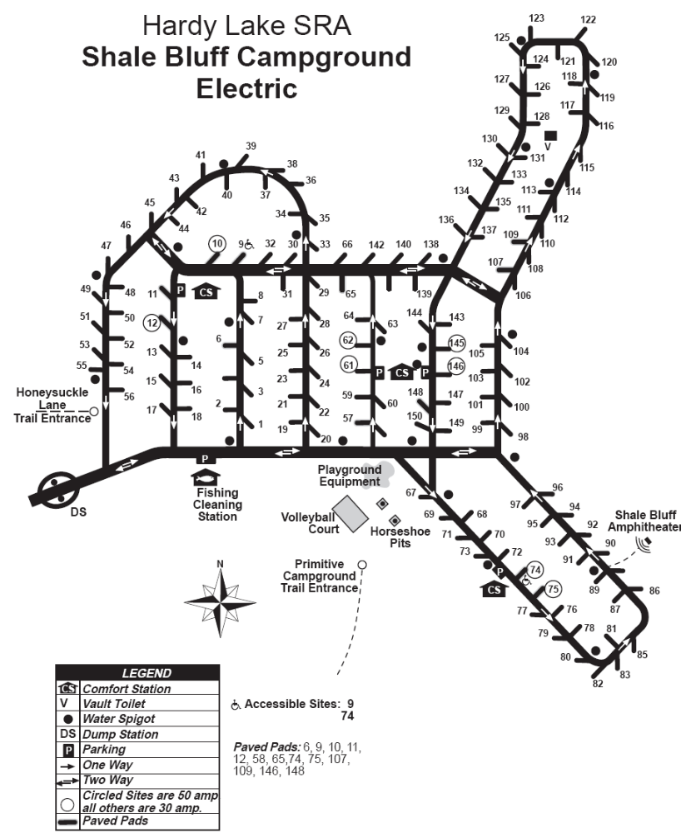
Monroe Lake
Activities and Facilities
- Boating / 9 Launch Ramps
- Fishing / Ice Fishing Fishing Piers
- Fourwinds Resort & Marina Gas Dock
- Hiking Hunting (Waterfowl Hunts)
- Interpretive Naturalist Services (Seasonal) Nature Center
- Picnicking / Shelterhouse (Shelter Reservations) Playgrounds
- Rental - Fishing Boats, Pontoons
  - Lake Monroe Boat Rental Pleasure Craft Marina Fourwinds Boat Rental
- Swimming / 2 Beaches (See Swim Alert) Waterskiing
- Local map Property Map
- Local tourism info
- Regional tourism info
- Paynetown electric, non-electric Paynetown non-electric
- Fairfax SRA Hiking Trail maps Campground reservations Google Map
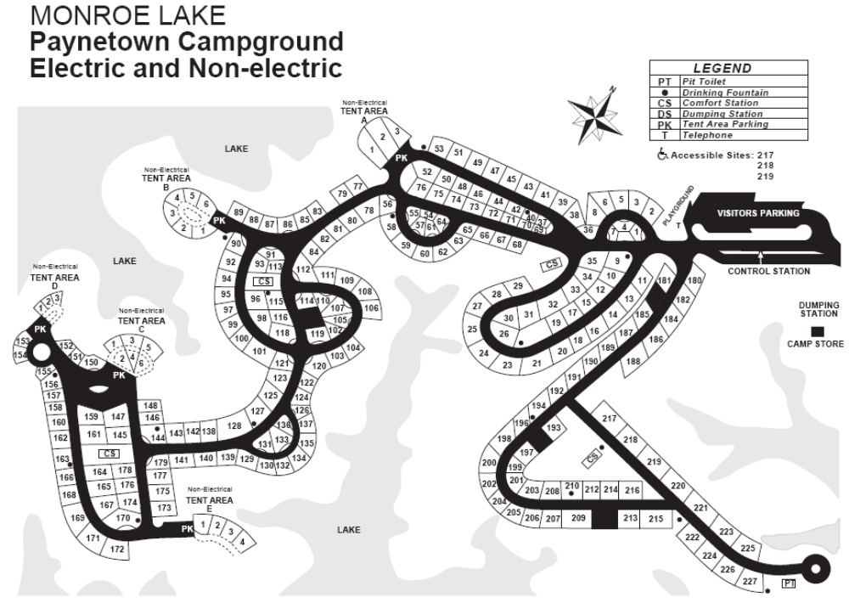

Patoka Lake
Activities & Facilities
- Archery Range Boating / 10 Launch Ramps Cross-country skiing
- Fishing / Ice Fishing Disc Golf Course
- Gilligan's Boats (www.gilligansboats.com)
- Hiking / Fitness / Biking Trails
- Hunting Interpretive / Recreational Programs
- Picnicking / Shelterhouse (Shelter Reservations)
- Swimming / Beach (See Swim Alert) Waterskiing
- Local map Property Map Campground reservations
- Electric 1-245
- Electric 246-367
- Fishermen youth
- Hoosier Hills Marina
- Patoka Lake Marina Google Map
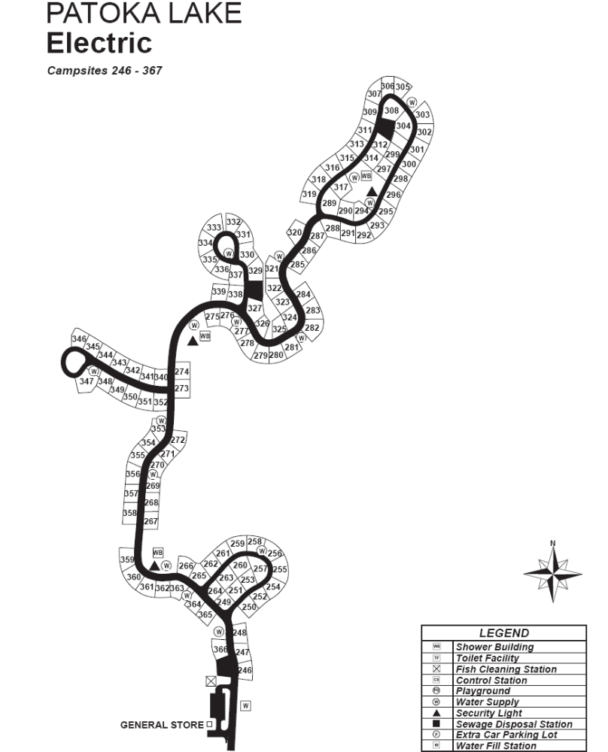
Prophetstown
Activities and Facilities
- Shelters (Shelter Reservations)
- Hiking Trails
- Bicycle Trail
- Camping
- Interpretive Naturalist Services (seasonal)
- Photo Gallery
- Local tourism info
- Regional tourism info
- Property Map Campground reservations
- Full hookup & electric Google Map
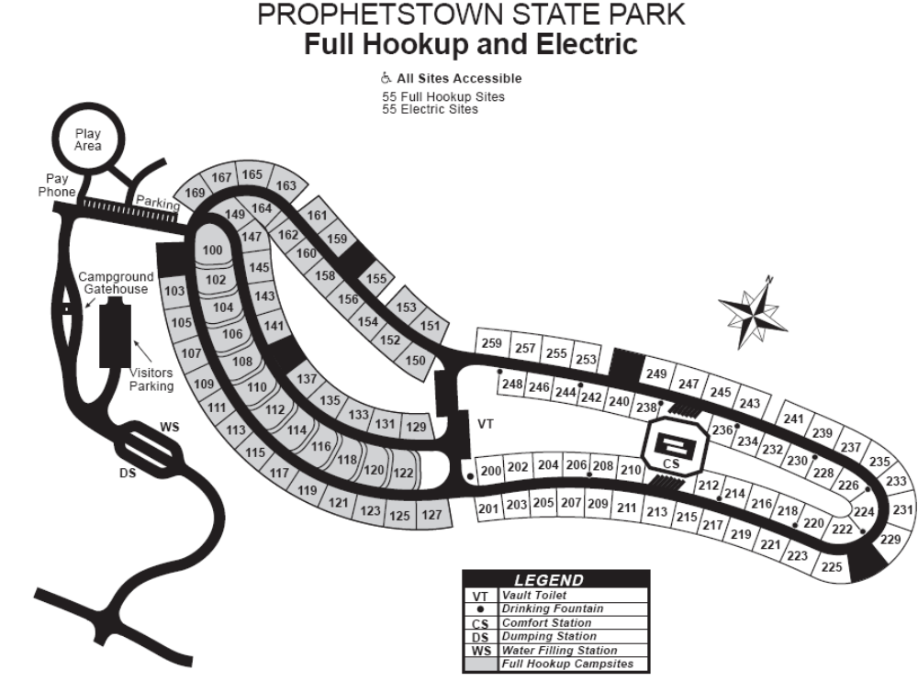

Shades
Activities and Facilities
- Picnic areas w/shelters
(Shelter Reservations)
- Hiking Trails
- Fishing
- Interpretive Naturalist Services (Seasonal)
- Local Map
- Local tourism info
- Regional tourism info
- Property Map Campground reservations
- Non-electric
- Google Map

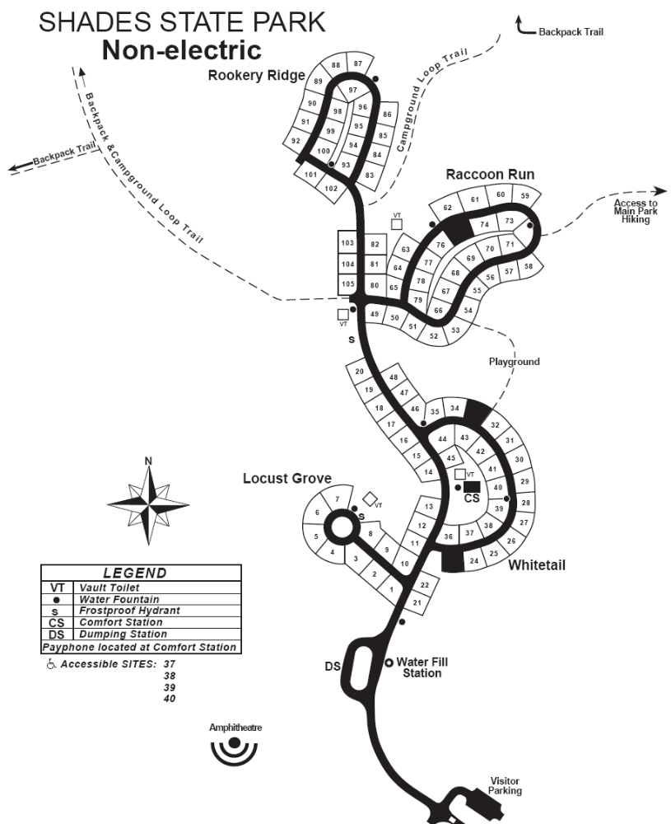
Turkey Run
Activities and Facilities
- Picnic areas w/shelter (Shelter Reservations)
- Interpretive Naturalist Services Nature Center / Planetarium
- Cabins, Inn Operated Rental - Cultural Arts Programs
- Fishing Hiking Trails
- Turkey Run Inn Accommodations
w / Indoor Pool toll free 1-877-500-6151
- Inn Restaurant Meeting & Conference Facilities
- Playgrounds
- Saddle Barn with escorted rides (765) 597-2280
- Tennis & Other Games Swimming / Pool (See Swim Alert)
- Turkey Run Inn Inn Reservations
- Meeting & Conference Facilities Inn operated cabins
- Local Map Property Map
- Local tourism info Regional tourism info
- Electric Campground reservations
- Youth tent areas Google Map

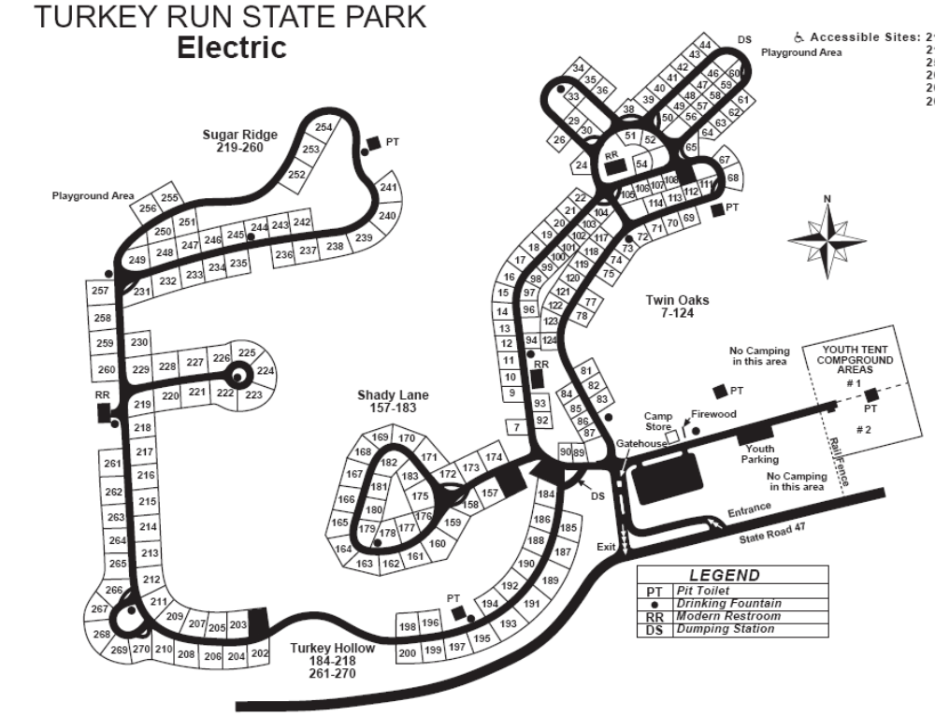

Cagles Mill Lake
Activities and Facilities
- Nature Center
- Basketball Court
- Boating / 2 Launch Ramps
- Fishing
- Fishing Pier
- Hiking Trails
- Horseshoe Pits
- Hunting
- Interpretive Naturalist Services
- Picnicking / Shelterhouse
- Playground Equipment
- Rental - Fishing Boats, Pontoons
- Waterskiing
- Water Safari Boat Tours Swimming / Pool / Waterslide
- Local map Property Map Regional tourism info
- Poplar Grove electric Sunny Acres non-electric Cataract Falls SRA Campground reservations Google Map
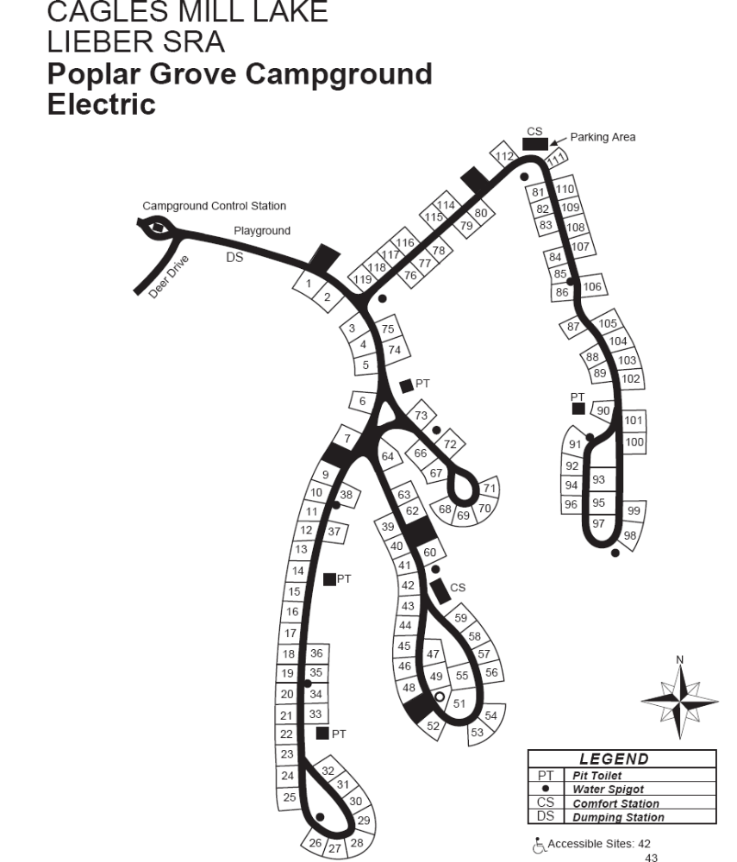
Cecil M. Harden Lake (Raccoon SRA)
Activities and Facilities
- 1880's Roller Mill Tours and Corn Grinding Demonstrations
- Archery Range Basketball Courts Boating / 5 Launch Ramps
- Fishing / Ice Fishing Fishing Pier (open when water level permits)
- Hiking Trails Horseshoe Pits Hunting / Limited Interpretive Services
- Picnicking / Shelterhouse Playground Equipment
- Rental - Fishing Boats, Pontoons Swimming / Beach (See Swim Alert)
- Local map Property Map Electric/non-electric Campground reservations Google Map

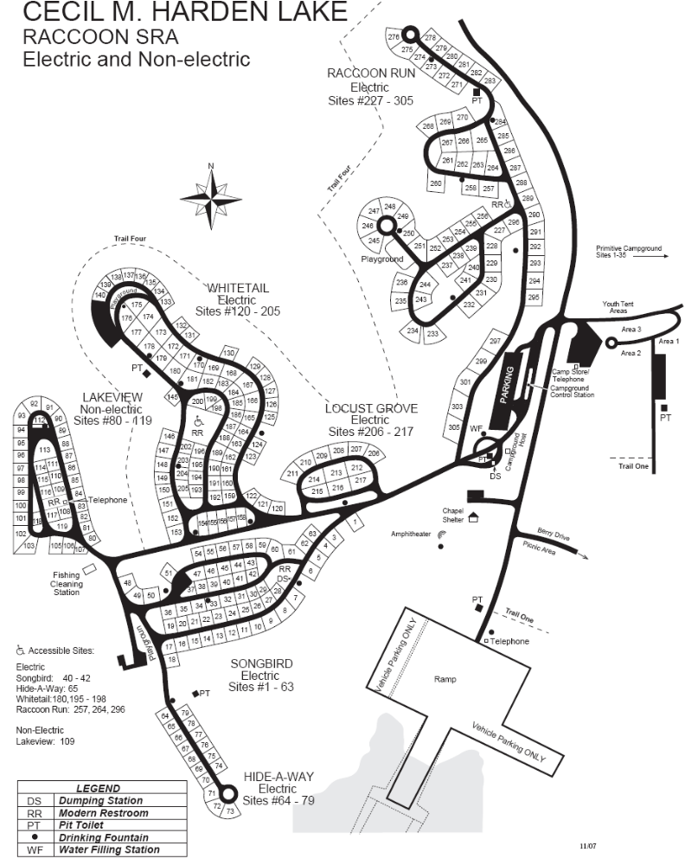
Fort Harrison
Activities and Facilities
- Recreation Buildings equipped with kitchenettes and restrooms (Recreation Building Reservations)
- Nature Center/Interpretive Naturalist Services Shelters (Shelter Reservations)
- Picnicking Hiking Trails / Multi-use Trail (paved)
- Bicycle Trail Fishing
- Saddle Barn w/ horse trail rides, hay rides
http://www.hoosiertrailrides.com/, (317) 541-1866
- Inn Restaurant Ice Fishing
- Sledding hill and cross country skiing Shelters (one shelter equipped with fireplace)
- The Garrison
- Inn Reservations
- The Fort Golf Resort & Conference Center
- Local map
- Local tourism info
- Regional tourism info
Maps
Property Map (trails) Google Map

Mounds
Activities and Facilities
- Visitor Center and Gift Shop/Interpretive Naturalist Services
- Picnicking/Shelters
(Shelter Reservations)
- Hiking Trails
- Fishing (White River)
- Rental - Recreation Building
- Camp Store
- Swimming / Pool
- Local map Property Map Electric Campground reservations
Google Map

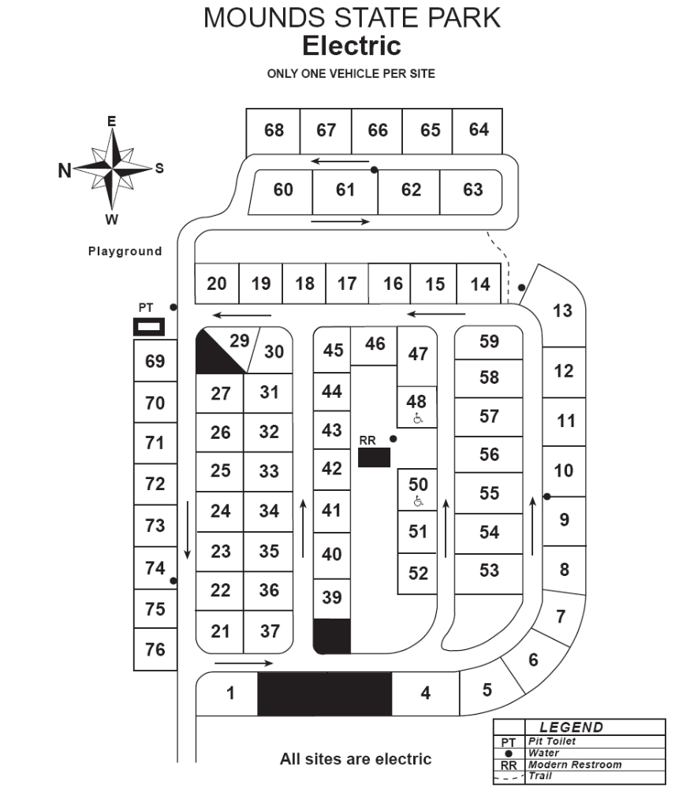
Summit Lake
Activities and Facilities
- Picnic areas w/shelter (Shelter Reservations) Interpretive Naturalist Services (Seasonal)
- Three Boat Launch Ramps Boat Motor / Idle speed only
- Cross County Skiing / No Ski Rental
- Fishing / Ice Fishing
- Hiking Trails Rental-Canoe, Paddleboat, Rowboat Swimming / Beach 2008 Goose Reductions
Local Map Property Map Local tourism info
- Electric camping Youth tent camping Campground reservations Google Map



